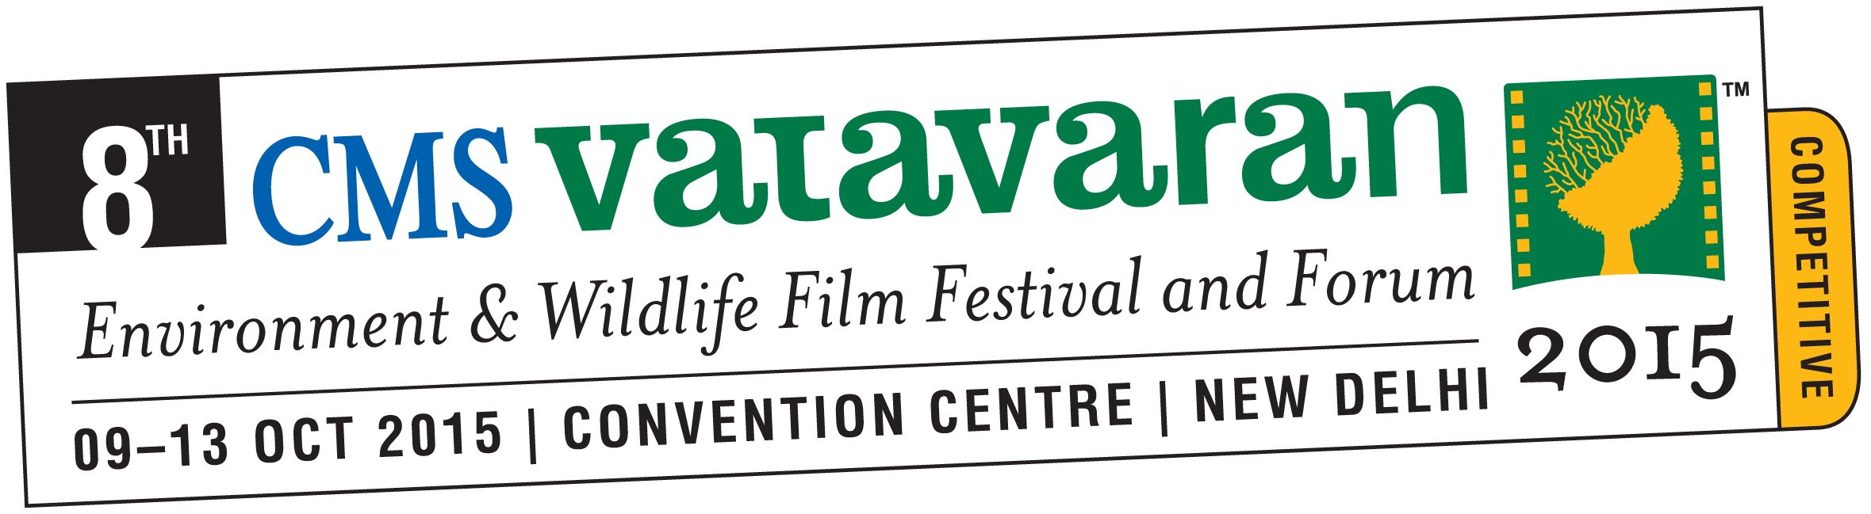

Eminent Actor Mr Amol Palekar heads the 8th CMS VATAVARAN Award Jury.
The 8th CMS VATAVARAN Award Jury Meet is being held at Le Meridien Hotel in New Delhi
August 27, 2015, New Delhi: Mr Amol Palekar, eminent actor and filmmaker is heading a 10 member jury for the coveted CMS VATAVARAN Environment & Wildlife Film Festival Awards which is being held from August 26th to 28th at the Le Meridien in New Delhi. The award jury members are viewing all the seventy-five films that have been nominated to select the winners in each category. A total of 52 Indian films are competing in 8 categories, while 23 International films are competing in 5 categories.
The 8th CMS VATAVARAN Jury Committee comprises of jury members from widely divergent sectors and streams including cinema, conservation, media and academia. The jury members include Mr George Kutty (Founder Director of Voices from Water), Mr Joe Madiath (Founder, Chairman of Gram Vikas), Dr K P Jayashankar (Professor and Dean of SMCS, TISS), Mr M C Mehta (Supreme Court Lawyer & Environmentalist), Ms Namrata Joshi (Film Critic, The Outlook), Ms Ravi Agarwal (Founder Director of Toxics Link), Ms Ritu Sarin (Festival Director of Dharamshala International Film Festival), Ms Sanchaita Gajapati Raju (Founder of Social Awareness, Newer Alternatives) and Mr Saibal Chatterjee (Film Critic). The Indian film Jury is headed by Shri Amol Palekar and the International film Jury is headed by Mr Girish Kasaravalli (padmashri and award winning film maker).
In all, this Jury will decide 23 awards in 8 Indian categories and 5 International categories. The eminent jury members will also be selecting two Best of the Festival Awards out of the 75 nominees.
Mr Amol Palekar, who is heading the Award Jury for the second time in a row, said, “CMS VATAVARAN is an important endeavour that everyone needs to support. Films are a powerful medium to address important issues to the masses.” He has also been appointed as the Jury Chairperson to select the Indian entry to the Oscars recently.
Ms P N Vasanti, Director General of CMS, who is also leading this film festival said, “The theme of the film festival is Water for Life this year and the festival is significant because it will allow us to deliberate on important issues and promote conservation methods through these award winning films in different sections of our society.”
The awards will be conferred on October 11th, 2015 during the 8th CMS VATAVARAN Environment & Wildlife International Film Festival and Forum at the Convention Centre, New Delhi.
CMS VATAVARAN received a total of 178 entries for the 8th edition, out of which 75 films were selected by the Nomination Jury Members in the month of June this year. The Nomination Jury was headed by Water Man of India and winner of the Stockholm Water Prize 2015, Mr Rajendra Singh.
All the nominated films will be screened at the 8th CMS VATAVARAN over five days from October 9th to 13^{th,} 2015 at the Convention Centre, New Delhi. Along with the film screenings, the film festival and forum will see a host of seminars focussing on the issue of water, workshops for children, teachers, filmmakers and filmmaking students, special panorama of wildlife films from Jackson Hole Wildlife Film Festival and water films from Voices from the Waters International Film Festival, Special Screening of Kaun Kitne Paani Mein (Directed by Nila Madhab Panda, starring Kunal Kapoor and Radhika Apte) and Aisa Yeh Jahaan (Directed by Biswajeet Bora, starring Dr Palash Sen and Ira Dubey).
About CMS VATAVARAN: CMS VATAVARAN is an initiative of Centre for Media Studies (CMS) to raise awareness on environment and wildlife issues through the medium of films. The film festival and forum is an effort to provide filmmakers a platform to reach out to its audiences, impact policy change and change perception of the people towards the issue. The CMS VATAVARAN film festival is organised in two different editions, with the competitive edition in New Delhi and the travelling edition in selected cities across India. The film festival was initiated in the year 2003 with the support of the Ministry of Environment, Forest and Climate Change. In the last 13 years, CMS VATAVARAN has organised more than 5000 screenings in more than 45 cities in India. It has reached out to various stakeholders which includes filmmakers, policy makers, conservationists, diplomats, students, academicians, defence personnel and the media. The platform of CMS VATAVARAN is also used to organise public forums to discuss on crucial environment issues for policy change. CMS VATAVARAN is a multi- partner initiative and encourages like-minded organisation and individuals with a shared goal to join hands in this green movement. Today, CMS VATAVARAN is an international environment and wildlife film festival with a wide network of filmmakers, partners in the environment and wildlife sector, corporations, embassies, organisations, academia, film industry, independent groups and the media.
For Media Interviews and other queries, please contact: Indira Akoijam, Communication Manager, CMS VATAVARAN, E:indira@cmsindia.org M: 9899979161

